

***Data Structure and Algorithm (Lab)***

***Assignment – 3***

**Name:**

Ali Maqsood.

**Roll no:**

SU92-BSAIM-F23-050.

**Department:**

Software Engineering Department.

**Program:**

Artificial Intelligence.

**Section:**

BSAI-3A

**Question # 1:**

**Objective**: Write a Python function that implements the **optimized Bubble Sort** algorithm. The optimization should include a **flag** that stops the algorithm if the array is already sorted before completing all iterations.

**Code:**

arr=[5,4,2,9,3,0]

def bubble(arr):

    counter=0

    print(f"Default Array: {arr}.")

    for i in range(len(arr)-1):

        flag = False

        for j in range(len(arr)-1-i):

            if arr[j]>arr[j+1]:

                flag = True

                counter+=1

                arr[j],arr[j+1]=arr[j+1],arr[j]

                print(f"Pass {counter}: {arr}.")

        if flag == False:

            print("Not swapped exiting early.....")

            break

    print(f"Total swaps: {counter}")

    return(counter)

bubble_sort=bubble(arr)

**Output:**

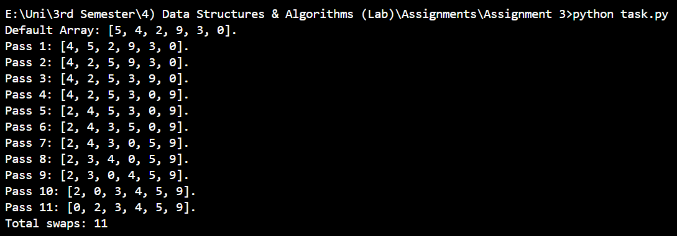

**Question # 2:**

**Objective**: Write a Python program that:

1. Sorts an array using **Bubble Sort** and counts the **total number of swaps** performed.
2. Sorts the same array using **Insertion Sort** and counts the **total number of swaps** performed.
3. Compares the number of swaps in both sorting algorithms.

**Code:**

arr=[5,4,2,9,3,0]

def bubble(arr):

    counter=0

    print(f"Default Array: {arr}.")

    for i in range(len(arr)-1):

        flag = False

        for j in range(len(arr)-1-i):

            if arr[j]>arr[j+1]:

                flag = True

                counter+=1

                arr[j],arr[j+1]=arr[j+1],arr[j]

                print(f"Pass {counter}: {arr}.")

        if flag == False:

            print("Not swapped exiting early.....")

            break

    print(f"Total swaps: {counter}")

    return(counter)

bubble_sort=bubble(arr)

arr=[5,4,2,9,3,0]

def insertion(arr):

    shifts=0

    print(f"Default Array: {arr}.")

    for i in range(1, len(arr)):

        shifts+=1

        key=arr[i]

        j=i - 1

        while j>=0 and arr[j]>key:

            arr[j + 1]=arr[j]

            j-=1

        arr[j + 1]=key

        print(f"Pass {i}: {arr}.")

    print(f"Total swaps: {shifts}")

    return(shifts)

insertion_sort=insertion(arr)

if bubble_sort<insertion_sort:

    print("Bubble sort is better")

elif insertion_sort<bubble_sort:

    print("Insertion sort is better")

else:

    print("Both are same")

**Output:**

